Test Problem

# Contents

Description 1

Orders input file 2

Supplier output file 2

Sample files 3

Input file orders23.xml 3

Output file Apple23.xml 3

Output file Panasonic23.xml 4

Output file Sony23.xml 4

# Problem description

SACOM is an electronic retailer that has multiple online and physical stores. SACOM needs a middleware application that can integrate the existing different ordering systems with the suppliers of electronic products.

SACOM customers place product orders from various locations and systems and these orders need to be processed and sent to the corresponding suppliers.

The orders are sent as XML files on a central server, where your application needs to process them and create the XML files that will be sent to the suppliers. Following is a system overview diagram:

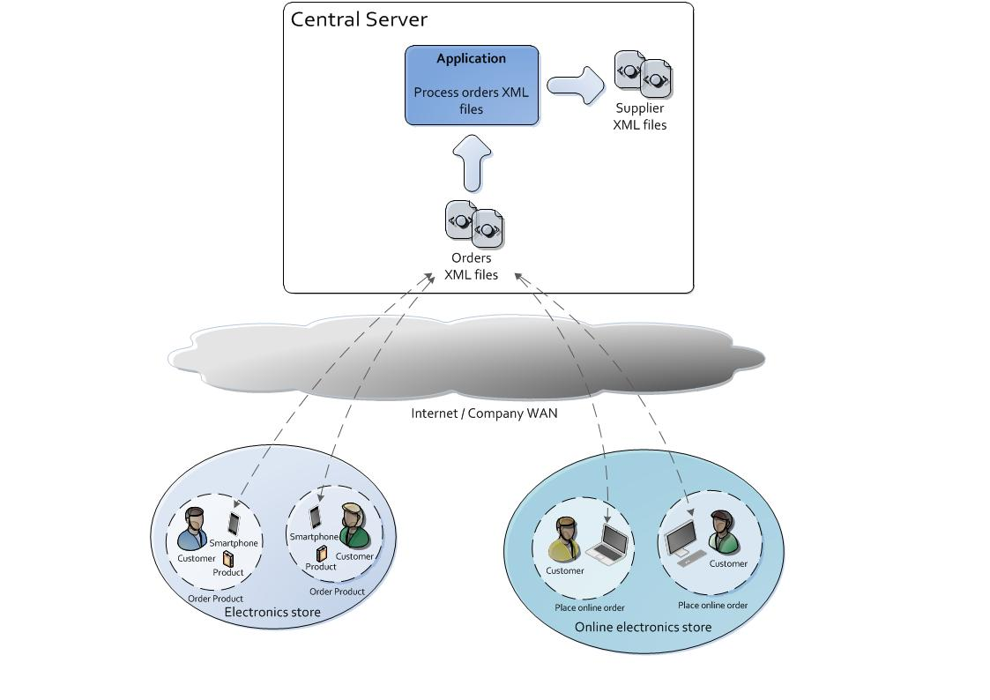

Each XML file that contains orders will be processed into multiple XML files, one file per each supplier. The supplier output file will contain all the supplier’s products from one orders file, sorted descendant by the timestamp when the order was created and product price. Each product that will be sent to the supplier must also contain the order ID, so that it will be easily tracked to the original order.

The application will wait for the orders files in one folder and will export the supplier files in a separate folder. Once a file that contains orders is received in the specific folder, the application will process it, and then it will wait for another orders file to process.

Once a customer places an order, he expects it to be delivered as soon as possible, so you must focus on the application XML files processing performance in order to keep the customers happy.

## Orders input file

The orders file name pattern is orders##.xml, where ## are digits. For example orders01.xml is a valid name and ordersss.xml is not. The structure of one XML file that contains orders is the following:

<?xml version=*"1.0"* encoding=*"UTF-8"*?>

<orders>

<order created=*'2012-07-12T15:29:33.000'* ID=*'2343'*>

<product>

<description>Sony 54.6" (Diag) Xbr Hx929 Internet Tv</description>

<gtin>00027242816657</gtin>

<price currency=*"USD"*>2999.99</price>

<supplier>Sony</supplier>

</product>

<product>

<description>Apple iPad 2 with Wi-Fi 16GB - iOS 5 - Black</description>

<gtin>00885909464517</gtin>

<price currency=*"USD"*>399.0</price>

<supplier>Apple</supplier>

</product>

<product>

<description>Sony NWZ-E464 8GB E Series Walkman Video MP3 Player Blue</description>

<gtin>00027242831438</gtin>

<price currency=*"USD"*>91.99</price>

<supplier>Sony</supplier>

</product>

</order>

<order created=*'2012-07-13T16:02:22.000'* ID=*'2344'*>

<product>

<description>Apple MacBook Air A 11.6" Mac OS X v10.7 Lion MacBook</description>

<gtin>00885909464043</gtin>

<price currency=*"USD"*>1149.0</price>

<supplier>Apple</supplier>

</product>

<product>

<description>Panasonic TC-L47E50 47" Smart TV Viera E50 Series LED HDTV</description>

<gtin>00885170076471</gtin>

<price currency=*"USD"*>999.99</price>

<supplier>Panasonic</supplier>

</product>

</order>

</orders>

## Supplier output file

The suppliers file name pattern is suppliername##.xml, where ## are the digits from the orders xml file processed. For example, after processing the orders23.xml that contains suppliers Apple, Sony and Panasonic, the program must create the suppliers files with the following names: Apple23.xml, Sony23.xml and Panasonic23.xml. The structure of one supplier XML file is:

<?xml version=*"1.0"* encoding=*"UTF-8"*?>

<products>

<product>

<description>Sony 54.6" (Diag) Xbr Hx929 Internet Tv</description>

<gtin>00027242816657</gtin>

<price currency=*"USD"*>2999.99</price>

<orderid>2343</orderid>

</product>

<product>

<description>Sony NWZ-E464 8GB E Series Walkman Video MP3 Player Blue</description>

<gtin>00027242831438</gtin>

<price currency=*"USD"*>91.99</price>

<orderid>2343</orderid>

</product>

</products>

# Sample files

After processing input file orders23.xml, the application must create three suppliers files: Apple23.xml, Panasonic23.xml and Sony23.xml. Following is the sample file content for reference.

## Input file orders23.xml

<?xml version=*"1.0"* encoding=*"UTF-8"*?>

<orders>

<order created=*'2012-07-12T15:29:33.000'* ID=*'2343'*>

<product>

<description>Sony 54.6" (Diag) Xbr Hx929 Internet Tv</description>

<gtin>00027242816657</gtin>

<price currency=*"USD"*>2999.99</price>

<supplier>Sony</supplier>

</product>

<product>

<description>Apple iPad 2 with Wi-Fi 16GB - iOS 5 - Black</description>

<gtin>00885909464517</gtin>

<price currency=*"USD"*>399.0</price>

<supplier>Apple</supplier>

</product>

<product>

<description>Sony NWZ-E464 8GB E Series Walkman Video MP3 Player Blue</description>

<gtin>00027242831438</gtin>

<price currency=*"USD"*>91.99</price>

<supplier>Sony</supplier>

</product>

</order>

<order created=*'2012-07-13T16:02:22.000'* ID=*'2344'*>

<product>

<description>Apple MacBook Air A 11.6" Mac OS X v10.7 Lion MacBook</description>

<gtin>00885909464043</gtin>

<price currency=*"USD"*>1149.0</price>

<supplier>Apple</supplier>

</product>

<product>

<description>Panasonic TC-L47E50 47" Smart TV Viera E50 Series LED HDTV</description>

<gtin>00885170076471</gtin>

<price currency=*"USD"*>999.99</price>

<supplier>Panasonic</supplier>

</product>

</order>

</orders>

## Output file Apple23.xml

<?xml version=*"1.0"* encoding=*"UTF-8"*?>

<products>

<product>

<description>Apple MacBook Air A 11.6" Mac OS X v10.7 Lion MacBook</description>

<gtin>00885909464043</gtin>

<price currency=*"USD"*>1149.0</price>

<orderid>2344</orderid>

</product>

<product>

<description>Apple iPad 2 with Wi-Fi 16GB - iOS 5 - Black</description>

<gtin>00885909464517</gtin>

<price currency=*"USD"*>399.0</price>

<orderid>2343</orderid>

</product>

</products>

## Output file Panasonic23.xml

<?xml version=*"1.0"* encoding=*"UTF-8"*?>

<products>

<product>

<description>Panasonic TC-L47E50 47" Smart TV Viera E50 Series LED HDTV</description>

<gtin>00885170076471</gtin>

<price currency=*"USD"*>999.99</price>

<orderid>2344</orderid>

</product>

</products>

## Output file Sony23.xml

<?xml version=*"1.0"* encoding=*"UTF-8"*?>

<products>

<product>

<description>Sony 54.6" (Diag) Xbr Hx929 Internet Tv</description>

<gtin>00027242816657</gtin>

<price currency=*"USD"*>2999.99</price>

<orderid>2343</orderid>

</product>

<product>

<description>Sony NWZ-E464 8GB E Series Walkman Video MP3 Player Blue</description>

<gtin>00027242831438</gtin>

<price currency=*"USD"*>91.99</price>

<orderid>2343</orderid>

</product>

</products>

# Deliverables

The following should be included in the delivery archive:

* Source files (it is preferred to send all the IDE project files)
* Compiled files
* Additional libraries used
* A readme file that contains a description of the solution